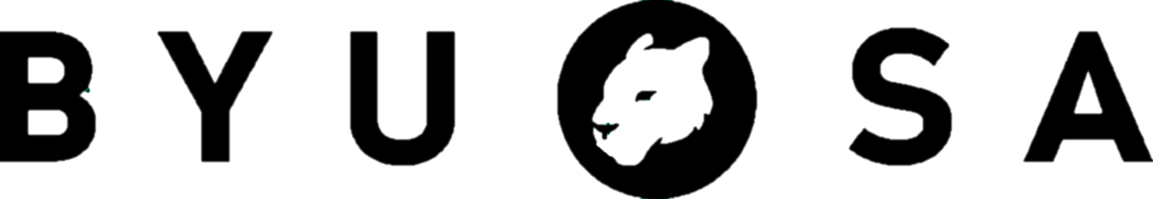

**VOTE FOR RAFAEL**

**It’s the**

**only way**

**his girlfriend**

**is going**

**to say yes.**

**YOU OWE HER THIS!**

**Remember that time Amanda gave you a dum-dum by the Tanner?**

**VOTE FOR AMANDA**

**VOTE FOR RAFAEL**

**His uncle is a General Authority so….he’s kind of a big deal.**

**She postponed her mission for this.**

**If this doesn’t work out, it’s on you.**

**VOTE FOR AMANDA**